EVC Marketing Guide 2
In association with CustomerCount

How to use the LinkedIn Mobile App “Find Nearby” feature

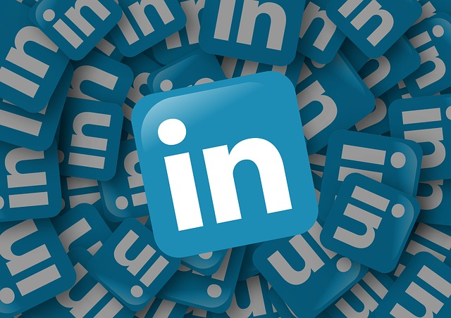

Attendees at conferences and events all search for fellow delegates to network, connect and keep in touch.

In today’s mobile society, access to smartphones and apps is paramount to be in touch and LinkedIn has enhanced its own mobile app with a brilliant feature to help find and connect with delegates.

In the age of data privacy, you are required to opt-in and you can only be discovered when your app is on the Find Nearby page. But not to worry, there is no data tracking or monitoring or location data being stored!

One slight downside is the range, which is often dependent on your smartphone device, and may be a maximum of ±30 meters. However, once you find a LinkedIn member, you can send a message or a direct invitation to connect – remember to personalise that invitation with a good reason to connect!

How to use LinkedIn Find Nearby in IOS
- On your smartphone, ensure your Bluetooth is activated
- Open the LinkedIn App and at the bottom of the screen, tap the MY NETWORK twin head image.
- At the top of the screen, next to the number of your connections, tap FIND NEARBY.
- If you receive a prompt to update settings or accessories simply follow the on-screen instructions, particularly the enable Bluetooth sharing for the LinkedIn app.
- Nearby members will then be displayed on your Find Nearby screen.
- Tap, view, connect or message current connections!

How to use LinkedIn Find Nearby in Android
- On your smartphone, ensure your Bluetooth is activated
- Open the LinkedIn App and at the bottom of the screen, tap the MY NETWORK twin head image.
- At the top of the screen, next to the number of your connections, tap FIND NEARBY.
- If you receive a prompt to update settings or accessories simply follow the on-screen instructions, particularly to allow the enable nearby Bluetooth setting for the LinkedIn app.
- Nearby members will then be displayed on your Find Nearby screen.
- Tap, view, connect or message current connections!

Are your connections aware of the Find Nearby feature?

One down side of this feature is simply that many LinkedIn members do not know that it exists. However, as many LinkedIn members have yet to update or configure their personal profiles for maximum visibility, that is hardly surprising.

On a positive note, those who will have this feature enabled will without doubt include members with significant connections/followers and may be a superb source of added value and content distribution. (More on that via EVC LinkedIn Training programmes).

You may even find yourself in the role of educator when identifying a potential connection and introducing them to the Find Nearby feature – presenting much more impact than the standard business card.

This approach will also offer immediate connection and post-event contact and networking opportunities.

Event marketing, including pre, current and post event strategies, can be the difference between a good and a great return on your time, travel and investment.

To maximise your visibility, EVC Marketing can provide a further guide to using LinkedIn, video, website content (blog and news), PR and additional social media channels for events and indeed for general digital marketing planning.

